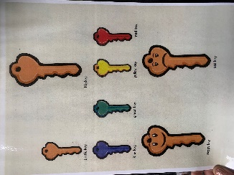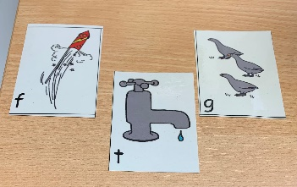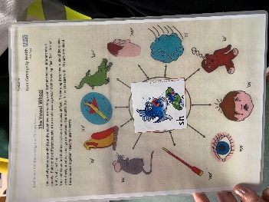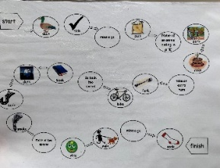

**Communication and Interaction Needs**

The SEND Code of Practice describes this as, ‘Children and young people with speech, language and communication needs (SLCN) have difficulty in communicating with others. This may be because they have difficulty saying what they want to, understanding what is being said to them or they do not understand or use social rules of communication. The profile for every child with SLCN is different and their needs may change over time. They may have difficulty with one, some or all of the different aspects of speech, language or social communication at different times of their lives.’

We use specialist advice for teaching approaches from CLASS and CITES, following consultation where required, to ensure Communication Friendly Practice in all classes. ‘Ready to Learn’ prompts are used in all classes to ensure children understand active listening. When appropriate, we use Languagelink resources to support teachers in planning and delivering lessons to support reduction in vocabulary gaps across the class. Children identified as needing support to acquire new or subject specific vocabulary receive pre-teaching. Wordbanks with visuals are available for all children.

**Referrals**

Referrals are needed for children to access:

* SALT (Speech and Language Therapy)
* Community Paediatrics (Autism assessment)

Please discuss any concerns about speech or language with your child’s class teacher or the SENCO.

**Communication and Interaction needs**

Some children will be identified through screening as requiring 1:1 or group support for speech or language. These sessions follow Speechlink and Languagelink. Speech: 5-10 mins 3 x weekly

Language: 20 mins 2 x weekly

specialist support from SALT (Speech and Language Therapy) through East Sussex CITES (Children’s Integrated Therapy Services)

**Group or 1:1 support**

**Screenings**

All children in Reception are screened using NELI (Nuffield Early Language Intervention) in Term 2 and Speech Link, as needed. Year 1 are screened using Infant Language Link, where language needs have been highlighted through NELI. All children in Year 3 are screened using Junior Language Link.

**Class strategies**

**SALT**

A few children may require a referral for